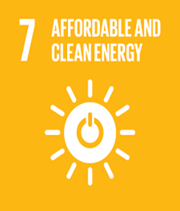**ARUBA**

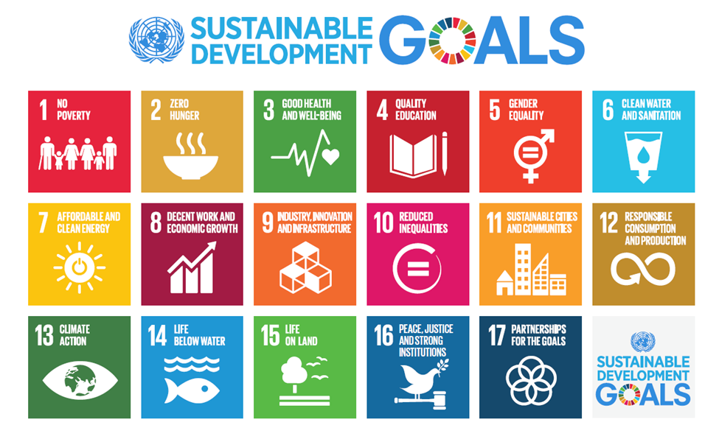

**Name: Kayvan Fletcher**

**Course: Environmental Science**

**Assignment: SDGs Aruba**

**Institute: University of Aruba**

**Lecturers: Christie Mettes**

**Tony Sevold**

**Date: November 26, 2017**

***Table of Contents***

Page

Describe what SDG target and goal your indicator is monitoring, and how? 2

Why is this SDG target and goal important to Aruba? 2

How does this SDG target and goal relate to waste management in Aruba? 3

Indicators monitoring 3

Statistics 4

***Describe what SDG target and goal your indicator is monitoring, and how?***

There are two SDGs targets and goals being monitored in this report. The official description of these two SDGs and its targets are:

*GOAL 7: “Ensure access to affordable, reliable, sustainable and modern energy for all”.*

TARGET 7.3: By 2030, double the global rate of improvement in energy efficiency.

This target is to aid improve and control the amount of energy that the world consumes, by using natural resources (sun and wind) that is able to us. This can be done by building windmills or solar panels to develop its renewable energy capabilities and limit its reliance on heavy fuel oil to generate power. Using this method, is most beneficial for any country, because it ensures stability of renewable energy output in case of shortages. Moreover, it will reduce energy cost and enable more people to store energy and sell it back to the government.

*GOAL 8: “Promote sustained, inclusive and sustainable economic growth, full and productive employment and decent work for all”.*

TARGET 8.1: Sustain per capita economic growth in accordance with national circumstances and, in particular, at least 7 per cent gross domestic product growth per annum in the least developed countries.

This target illustrates how the economic growth in an island is changes over the years. It focuses on the “increasing labor productivity, reducing the unemployment rate, especially for young people, and improving access to financial services and benefits are essential components of sustained and inclusive economic growth” (<https://sustainabledevelopment.un.org/sdg8>).

Furthermore, it gives an overall view of the labor force and it implements labor laws to ensure that employees are being rightfully compensated for the labor they provide, and companies are following the rules and regulations to promote a heathy and prosperous work environment. Furthermore, this target reviews the national minimum wage annually, taking into account inflation and other societal developments on the island, then gives advice if the amount needs to be adjusted (<http://kvk.aw/images/pdf/documents/Changes_Labor_Law.pdf>).

***Why is this SDG target and goal important to Aruba?***

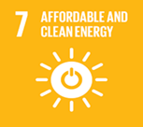**SDG target and goal 7** is important to Aruba because it aids the island by producing technology to utilize its energy and store it more effectively and efficiently. Moreover, since this goal had been implemented, electricity prices, which were US 33c/ KwH in 2009, have dropped 25% and are stable. In addition, inflation has been reversed; the island has nearly paid off the $300m it cost to switch out of diesel; the price of drinking water has fallen by almost a third; and the number of people unable to pay their bills has declined drastically (<https://www.theguardian.com/global-development/poverty-matters/2014/feb/10/wind-of-change-energy-policy-caribbean>).

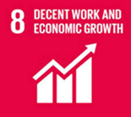Furthermore, **SDG target and goal 8** is also an important factor to Aruba, because it aids to reduce poverty. The labor laws provide the Aruban’s population with more opportunities for work and enable people without an education or low schooling to gain more for the minimum wages. The labor law policies reduced the unemployment and crime rate in Aruba, due to its new plans for the labor force (<http://kvk.aw/images/pdf/documents/Changes_Labor_Law.pdf>).



**SDG target and goal 7** relates to the waste management in Aruba, because it aids in reducing the high electricity prices that people on the island have been paying for many years. Moreover, the energy obtained from the windmills and solar panels are stored and available for usage even on days where there is no breeze, there is ample energy to sustain itself. Furthermore, Aruba has signed a “memorandum of understanding” with BYD Company Limited, to make all its public transportation system completely electric, which eliminates all greenhouse gas emissions from the vehicles themselves. This goal is most beneficial to Aruba because it aids the island reach its plan to be sustainably independent by 2020 (<http://www.sustainablebrands.com/news_and_views/clean_tech/carrie-thompson/how-aruba-plans-be-energy-independent-2020>). **SDG target and goal 8** relates to the waste management in Aruba, by the amount of tourist that visits the island. In other words, by the economic growth. This can have a negative impact of the community and the marine ecosystem, because having more people on the island means that their will be more waste. Aruba is a small island and if the population increases, we may not be able to maintain a sustainable waste management. Most tourist visit the island by cruise ships. Cruise ships pollute the ocean with the waste that it disposes, this is hazardous for the underwater animals.

***Indicator is being monitored in Aruba***

***INDICATOR 7.3.1:*** ***Energy intensity measured in terms of primary energy and GDP***

→ Energy intensity measured in terms of primary energy is being monitored in Aruba by the local Water (WEB) and Electricity (ELMAR) Company, Utilities Aruba and other stakeholders that provide a monthly update of the renewable energy watch (<https://www.webaruba.com/renewable-energy-dashboard/aruba>).

→ Energy intensity measured in terms of GDP is being monitored in Aruba by the World Bank (<https://data.worldbank.org/indicator/EG.EGY.PRIM.PP.KD?locations=AW>) and the United Nations (<https://en.wikipedia.org/wiki/List_of_countries_by_GDP_(nominal)>).

***INDICATOR 8.1.1: Annual growth rate of real GDP per capita***

→ The annual growth rate of real GDP per capita is being monitored in Aruba by the Department of Economic Affairs, Commerce & Industry of Aruba (<http://www.arubaeconomicaffairs.aw/index.php?option=com_content&task=view&id=54&Itemid=60>), the Aruban Government (<http://www.arubaforeignaffairs.com/afa/readBlob.do?id=3049>) and Central Bureau of Statistics – Aruba (<http://cbs.aw/wp/index.php/category/population/census/>).

***Statistics***

***Goal 7 - Ensure access to affordable, reliable, sustainable and modern energy for all***

***INDICATOR 7.3.1: - Energy intensity measured in terms of primary energy and GDP***

Energy intensity level of primary energy (MJ/$2011 PPP GDP)

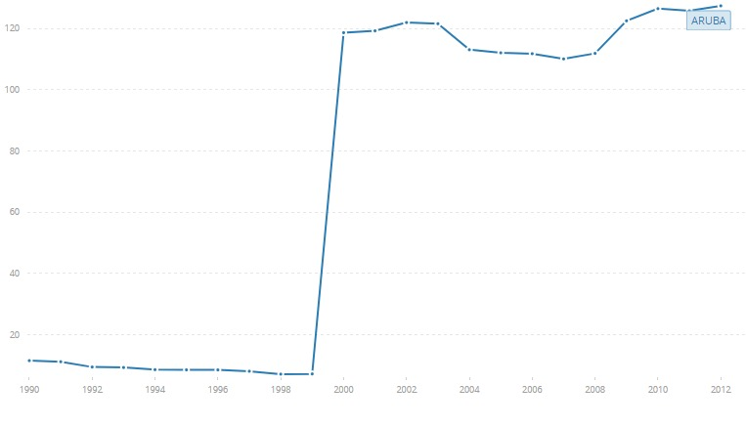

This table illustrate the energy intensity measure in terms of primary energy and GDP according to the World Bank, Sustainable Energy for All (SE4ALL) database from the SE4ALL Global Tracking Framework.

Primary energy intensity is obtained by dividing total primary energy supply over gross domestic product. Total primary energy supply, is made up of production plus net imports minus international marine and aviation bunkers plus-stock changes.

The share of renewable energy in final energy consumption grew modestly from 2012 to 2014, from 17.9 per cent to 18.3 per cent. Most of the increase was from renewable electricity from water, solar and wind power. Solar and wind power still make up a relatively minor share of energy consumption, despite their rapid growth in recent years. The challenge is to increase the share of renewable energy in the heat and transport sectors, which together account for 80 per cent of global energy consumption (<https://sustainabledevelopment.un.org/sdg7>).

***Goal 8 - Promote sustained, inclusive and sustainable economic growth, full and productive employment and decent work for all***

***Indicator 8.1.1 - Annual growth rate of real GDP per capita***

The GDP growth rate in Aruba is percent is 2.40 (<https://en.wikipedia.org/wiki/List_of_countries_by_real_GDP_growth_rate>).